Ratio Scale
# Source: AI Source: Provided by: [Data Path: Persons Table -> ID Column: 1, Name_En Column: Motasem Essam] -> From: [ChatGPT] on [7/17/2026]
The Ratio Scale is the highest level of measurement. It possesses all the characteristics of the other measurement scales—classification, ordering, and equal intervals—and, in addition, it has a true (absolute) zero point. Because of this true zero, both differences and ratios between values are meaningful.
The ratio scale is the most informative and versatile measurement scale, and it is the standard scale for most scientific, engineering, and physical measurements.

Definition
# Source: AI Source: Provided by: [Data Path: Persons Table -> ID Column: 1, Name_En Column: Motasem Essam] -> From: [ChatGPT] on [7/17/2026]
A Ratio Scale is a quantitative measurement scale in which values are ordered, equally spaced, and measured from a true zero point, allowing all arithmetic operations and meaningful ratio comparisons.

Purpose
# Source: AI Source: Provided by: [Data Path: Persons Table -> ID Column: 1, Name_En Column: Motasem Essam] -> From: [ChatGPT] on [7/17/2026]
The ratio scale is used to:
- Measure physical quantities.
- Compare differences and proportions.
- Perform all mathematical operations.
- Support advanced statistical analysis.
- Represent quantities where zero means the complete absence of the measured property.

Characteristics
# Source: AI Source: Provided by: [Data Path: Persons Table -> ID Column: 1, Name_En Column: Motasem Essam] -> From: [ChatGPT] on [7/17/2026]
A ratio scale:
- Classifies observations.
- Has a meaningful order.
- Has equal intervals between values.
- Has a true (absolute) zero.
- Allows meaningful ratios.
- Supports all arithmetic operations.

Properties
# Source: AI Source: Provided by: [Data Path: Persons Table -> ID Column: 1, Name_En Column: Motasem Essam] -> From: [ChatGPT] on [7/17/2026]
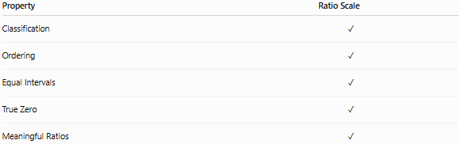
Property | Ratio Scale
Classification | ✓
Ordering | ✓
Equal Intervals | ✓
True Zero | ✓
Meaningful Ratios | ✓

True Zero
# Source: AI Source: Provided by: [Data Path: Persons Table -> ID Column: 1, Name_En Column: Motasem Essam] -> From: [ChatGPT] on [7/17/2026]
A true zero means the complete absence of the measured quantity.
Examples:
- 0 kg = no mass
- 0 m = no length
- 0 s = no elapsed time
- 0 K = minimum possible thermodynamic temperature
Because zero is absolute:
- 10 kg is twice 5 kg.
- 8 m is four times 2 m.

Examples
# Source: AI Source: Provided by: [Data Path: Persons Table -> ID Column: 1, Name_En Column: Motasem Essam] -> From: [ChatGPT] on [7/17/2026]
Length
Measurements:
- 0 m
- 2 m
- 5 m
- 10 m
Since zero means no length:
- 10 m is twice 5 m.

Mass
Measurements:
- 0 kg
- 25 kg
- 50 kg
Since zero means no mass:
- 50 kg is twice 25 kg.

Time Duration
Measurements:
- 0 s
- 30 s
- 60 s
60 seconds is twice 30 seconds.

Distance
Measurements:
- 0 km
- 10 km
- 40 km
40 km is four times 10 km.

Temperature (Kelvin)
Kelvin is a ratio scale because:
0 K represents absolute zero, the lowest possible thermodynamic temperature.
Example:
200 K is twice 100 K.

Area
Area has a true zero.
Example:
20 m² is twice 10 m².

Volume
Volume has a true zero.
Example:
6 L is three times 2 L.

Mathematical Operations
# Source: AI Source: Provided by: [Data Path: Persons Table -> ID Column: 1, Name_En Column: Motasem Essam] -> From: [ChatGPT] on [7/17/2026]
All arithmetic operations are meaningful.
Addition
5 kg + 3 kg = 8 kg

Subtraction
8 m − 3 m = 5 m

Multiplication
2 × 4 kg = 8 kg

Division
12 m ÷ 3 = 4 m

Ratios
20 kg ÷ 10 kg = 2
Meaning:
20 kg is twice 10 kg.

Statistical Measures
All common statistical methods may be used.
Examples:
- Mean
- Median
- Mode
- Range
- Variance
- Standard deviation
- Correlation
- Coefficient of variation
- Geometric mean
- Harmonic mean

Applications
# Source: AI Source: Provided by: [Data Path: Persons Table -> ID Column: 1, Name_En Column: Motasem Essam] -> From: [ChatGPT] on [7/17/2026]
Ratio scales are used extensively in:
- Physics
- Engineering
- Chemistry
- Biology
- Medicine
- Manufacturing
- Construction
- Economics
- Scientific research
- Mathematics

Advantages
# Source: AI Source: Provided by: [Data Path: Persons Table -> ID Column: 1, Name_En Column: Motasem Essam] -> From: [ChatGPT] on [7/17/2026]
The ratio scale:
- Provides the highest level of measurement.
- Supports all mathematical operations.
- Allows meaningful ratio comparisons.
- Enables the widest range of statistical analyses.
- Accurately represents physical quantities.

Limitations
# Source: AI Source: Provided by: [Data Path: Persons Table -> ID Column: 1, Name_En Column: Motasem Essam] -> From: [ChatGPT] on [7/17/2026]
Although very powerful, ratio scales:
- Cannot be used for qualitative categories.
- Require a genuine absolute zero.
- Are not appropriate for quantities with arbitrary zero points (such as Celsius temperature).

Common Mistakes
# Source: AI Source: Provided by: [Data Path: Persons Table -> ID Column: 1, Name_En Column: Motasem Essam] -> From: [ChatGPT] on [7/17/2026]
- Confusing ratio scales with interval scales.
Incorrect:
40°C is twice 20°C.
Correct:
40 K is twice 20 K.

- Assuming every numerical scale has a true zero.

- Treating interval measurements as ratio measurements.

Ratio Scale vs. Interval Scale
# Source: AI Source: Provided by: [Data Path: Persons Table -> ID Column: 1, Name_En Column: Motasem Essam] -> From: [ChatGPT] on [7/17/2026]
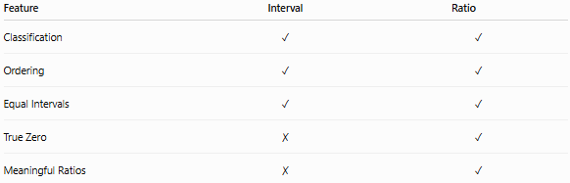
Feature | Interval | Ratio
Classification | ✓ | ✓
Ordering | ✓ | ✓
Equal Intervals | ✓ | ✓
True Zero | ✗ | ✓
Meaningful Ratios | ✗ | ✓
Example:
Interval:
- Celsius temperature
Ratio:
- Kelvin temperature

Ratio Scale vs. Ordinal Scale
# Source: AI Source: Provided by: [Data Path: Persons Table -> ID Column: 1, Name_En Column: Motasem Essam] -> From: [ChatGPT] on [7/17/2026]
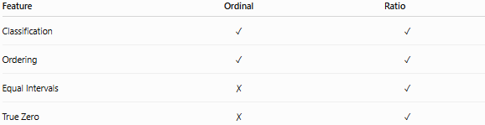
Feature | Ordinal | Ratio
Classification | ✓ | ✓
Ordering | ✓ | ✓
Equal Intervals | ✗ | ✓
True Zero | ✗ | ✓

Comparison of Measurement Scales
# Source: AI Source: Provided by: [Data Path: Persons Table -> ID Column: 1, Name_En Column: Motasem Essam] -> From: [ChatGPT] on [7/17/2026]
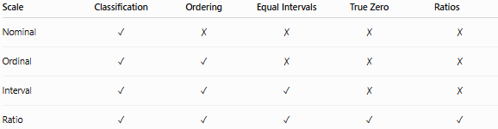
Scale | Classification | Ordering | Equal Intervals | True Zero | Ratios
Nominal | ✓ | ✗ | ✗ | ✗ | ✗
Ordinal | ✓ | ✓ | ✗ | ✗ | ✗
Interval | ✓ | ✓ | ✓ | ✗ | ✗
Ratio | ✓ | ✓ | ✓ | ✓ | ✓

Examples of Ratio Scale Measurements
# Source: AI Source: Provided by: [Data Path: Persons Table -> ID Column: 1, Name_En Column: Motasem Essam] -> From: [ChatGPT] on [7/17/2026]
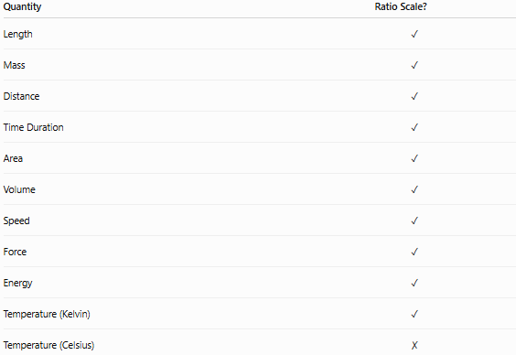
Quantity | Ratio Scale?
Length | ✓
Mass | ✓
Distance | ✓
Time Duration | ✓
Area | ✓
Volume | ✓
Speed | ✓
Force | ✓
Energy | ✓
Temperature (Kelvin) | ✓
Temperature (Celsius) | ✗

Key Points
# Source: AI Source: Provided by: [Data Path: Persons Table -> ID Column: 1, Name_En Column: Motasem Essam] -> From: [ChatGPT] on [7/17/2026]
- The Ratio Scale is the highest level of measurement.
- It has:
  - Classification
  - Ordering
  - Equal intervals
  - A true zero
- All arithmetic operations are meaningful.
- Ratios such as "twice as much" or "half as much" are valid.
- Most physical measurements in science and engineering use the ratio scale.

Conclusion
# Source: AI Source: Provided by: [Data Path: Persons Table -> ID Column: 1, Name_En Column: Motasem Essam] -> From: [ChatGPT] on [7/17/2026]
The Ratio Scale is the most comprehensive and informative measurement scale, combining classification, ordering, equal intervals, and a true zero point. Because zero represents the complete absence of the measured quantity, both differences and ratios are meaningful, allowing the full range of mathematical and statistical operations. Quantities such as length, mass, distance, time duration, area, volume, force, energy, and temperature measured in Kelvin are all measured on the ratio scale. Its precision and flexibility make it the preferred scale for scientific, engineering, medical, and mathematical applications.

